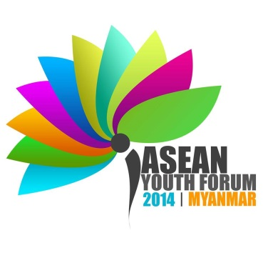

ASEAN YOUTH FORUM 2014

**Myanmar National Youth Congress**

**MEDIA CONFERENCE**

**ASEAN Youth Forum, in Conjunction with the ASEAN Summit 2014**

**“The Journey of ASEAN Youth to Naypyitaw”**

**Media Conference**

The ASEAN Youth Forum (AYF) is honoured to be invited for an official meeting with all ten of the ASEAN government leaders on 11th May 2014. This is the first time that the ASEAN Summit has provided a space for the ASEAN Youth Forum to share the most pressing issues and urgent needs of the youth in the region.

Prior to the ASEAN Summit, a youth civil society consultation was organised in March 2014, in which the ASEAN Youth Forum (AYF) came up with the Yangon Declaration-ASEAN Youth Statement 2014. The statement is a loud and clear call for a sustainable rights-based, inclusive, people-centred, and youth-driven regional community. Among our demands are recognition and meaningful participation of ASEAN youth voices, accessible of formal and non-formal education, and the immediate reform of discriminatory policies and laws towards vulnerable youth groups, which include ethnic minorities, sexual minorities and migrant workers.

We strongly call for the full recognition of the ASEAN Youth Forum as a youth-based, autonomous and independent regional institution that represents the voices of young Southeast Asians, and to monitor and evaluate the implementation of youth-related policies, agenda and recommendations.

In conjunction with the ASEAN Summit 2014, AYF will be holding a press conference this evening (18:00-9 10 May 2014). This would be a perfect opportunity for the media to access the pressing youth issues that for many years have been unheard.

For more information, please contact:

Contact Person: **Thet Swe Win**

Contact No. 09 **4200 29 616**

Press Conference:

Venue: **Lobby of the Golden Myanmar Hotel, Naypyidaw**

Time: **6:00 pm – 7:00 pm**