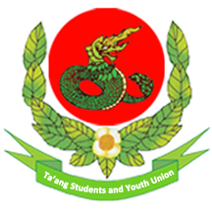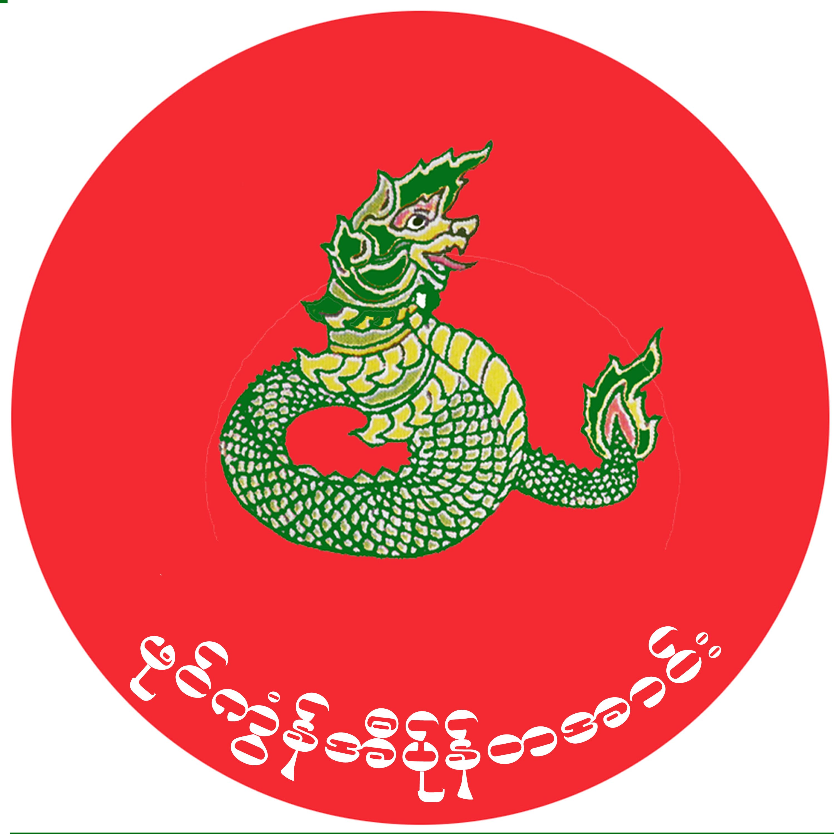

**Joint Statement of TWO and TSYU on human right violations in Ta’ang areas committed by the Burmese military troops and Militias**

**Date – 5, Jan, 2015**

1. The joint forces of Light Infantry Battalion (LIB) 324 , the Myanmar Army, and the Pansay militia firedartillery rounds towards Say Kin village, Namkham Township, Muse District and then entered the village on December 23, 2015 on 10 AM. The forces also arrested some Say Kin villagers and tortured them without any reason by forcing them to lay on the ground with their hands tied and beating with guns and rods.

2. They arrested 81 people from the villages of Say Kin, Man Puu, Pan Yoke, Man Pann villages, under Man Puu group, Namkhan Township. Among of them, the forces tortured 11 men including U Mai Myat Aung who lives in Ho Mon quarter, Muse District and released them on December 24, 2015 on 9 AM.

3. The Burmese army and Pan Say Militias also destroyed and intruded into the villagers' houses without permission. They also looted villagers’ properties including TVs, sewing machines, solar panels, phones, money, gold, and food, such as rice, oil, salt and tinned fish worth about three hundred million Kyat (over USD 229,000), and 24,000 Chinese yuan (about USD 3,600).

4.President Thein Sein and Commander in Chief Min Aung Hlaing have publicly told the domestic and international audience that peace is essential to our country. In addition to that the army and ethnic armed forces are about to hold political dialogue as the result of the National Ceasefire Agreement and the political frameworks for which they have spent many years to achieve. So, in the current situation, the government troops violated the rule granted under the Nation wide Ceasefire Accord - NCA section (5) and section (9), it will be a huge challenge for making peace and building public thrust to threaten, detain, torture the innocent people from these ethnic remote areas and destroying and looting their properties. So we, TSYU and TWO, seriously condemn the army's actions and demand an immediate stop to them.

5. Fighting between two opposite armed forces for the dominance of ideologies is understandable. But taking local innocent people as hostages and destroying the safety and security of people are against the Convention against Torture and other Cruel, Inhuman or Degrading Treatment or Punishment, Geneva Convention Protocol as well as the UDHR section (5) and section (3), and condemnable.

6. We, TWO and TSYU, demand that the army and pro-government militias stop arresting and torturing innocent, powerless and unarmed people, looting and destroying their properties. The government must also take the responsibility by ensuring that there are compensating for the loss and grievances caused by the army and the militias.

7. So we demand that the government do as follows;

* Take full responsibility for doing justice to the arrested and tortured villagers
* Stop threatening, illegally detaining and torturing the innocent people from these ethnic remote areas and destroying and looting their properties.
* Stop arbitrary firing both small and heavy into and around ethnic villages as a way to clear their way
* Follow and respect the international conventions and agreements on war to the books
* Stop advancing and establishing and dismantling them army bases in ethnic areas
* Stop offensives completely and immediately in the ethnic areas

**Ta’ang Women’s Organization – TWO**

**Ta’ang Students and Youth Organization – TSYU**

**Contact:**

**Lway Poe Ngeal - +95 0973063017**

**Mai Cyruk - + 95 09263011076**