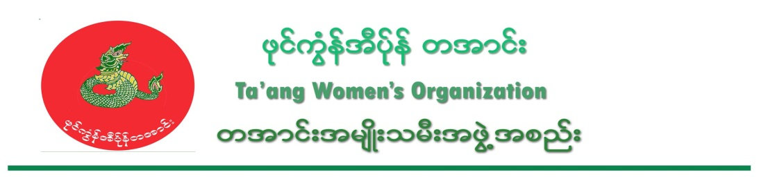
TWO condemns arrest of over 30 Ta’ang villagers by RCSS/SSA

Date – 10, June, 2016

On 8 June, 2016, the Restoration Council of Shan State (RCSS/SSA) arrested over 30 villagers from Bonn Swinn village and Jone Kalann village in Manton Township. The RCSS/SSA arrested the villagers who were working in a corn farm at 11 am. Among the 30 villagers, only 24 villagers are accounted for and 6 people have disappeared.

The names of the villagers are (1) Mai Aik Naing To, (2) Mai Aik Lom Dyat, (3) Mai Aik Nyi Kham, (4) Mai Nyi Khin, (5) Mai Aik Linn, (6) Mai Aik Kaung, (7) Mai Yaing Kyain, (8) Mai Maung Ngnee from Man Sat (Jone Ja) village, (9) Mai Lom Kha, (10) Mai Naing Tun, (11) Mai Naing Oo, (12) Mai Aung Myatt, (13) Mai Naing Mg Nyunt, (14) Mai Nyi Kitt, (15) Mai Nyi Kham Lonn, (16) Mai Naing Thamm, (17) Mai Nyi Maung from Man Ei Village, (18) Mai San Yon, (19) Mai Yaing Kyin, (20) Mai Sar Oo, (21) Mai Yaing Do, (22) Mai Nyi Yamm, (23) Mai Aik Kham and (24) Mai Kyam Sar from Jone Kalan village. Among the 24, 19 villagers have been released and five villagers are still under arrest.

One villager who was released said, “We were working in a corn farm. The RCSS came and shot at our tent in the corn farm first, but luckily there was nobody in the tent. We were all working at the corn farm. They surrounded us and arrested us. After they took us to the forest, they beat us. They beat our heads and slapped our faces. Mai Aik Linn, who hasn’t been released yet, was beaten on his whole body. He got wounded on his body and face. His face was swollen and he was bleeding in his mouth.”

Then, on 9 June, 2016, the RCSS/SSA arrested four villagers from Lwae Monn village and two girls from Jone Kalam village, altogether six villagers. They are (1) Mai Aik Nyi Maung, (2) Mai Aik Naing Kyaw, (3) Mai A Yaing To, (4) Mai Aik Naing Mg Win and 2 girls, (1) Lway Yay Kit and her friend (unknown). The villagers don’t know yet where they are being detained.

RCSS/SSA also destroyed and grabbed phones, food and livestock (chickens) from the village without permission of villagers.

Therefore, TWO strongly condemns the human right violations committed by RCSS/SSA against local communities.

IDRD
Ta’ang Women’s Organization – TWO
------------------------------

On 10, June, 2016, the RCSS/SSA arrested nine villagers from Sun Hote village at Manton township.

On 10, June 2016, the RCSS/SSA fired into Sun Hote village first at 5:30 pm, and arrested nine villagers who are male. The women and children fled to Taw Nay village.

One local women said, “When the RCSS/SSA came into our village, they fired inside the village first. Then they arrested men. When we heard the sound of firing, we ran with our children. They destroyed 10 households in the village and threatened us. They yelled that, they would destroy all of our houses as we allowed TNLA soldiers to stay in the village. If you are not satisfied, go to hell.”

The RCSS arrested 30 villagers on 8 June, 2016 and arrested six villagers including two underage girls on 9 June, 2016. TWO is very concerned that innocent villagers are being arrested and tortured, and their houses destroyed. TWO strongly condemns the human rights violations of RCSS and urges them to stop committing these violations.

IDRD
TWO

