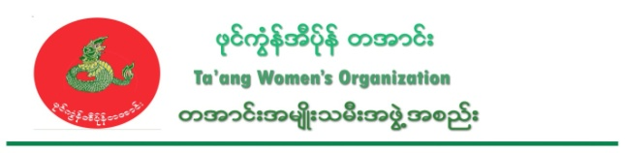
TWO’s statement on killing of innocent villagers by RCSS

Date- 9 June, 2016

TWO condemns the RCSS for laying a landmine that killed one villager, and for arresting and killing two villagers in Namkham on June 1-3, 2016.

On June 1, 2016, a villager from Kyuu Sai village, Namkham township, northern Shan State stepped on a mine and died immediately. 22-year-old Mai Lom Aung Kyi, sone of U Yaing Kham and Daw Ai Mawe, went to his tea farm and stepped on a land mine at 11 am, while he was going to look at his charcoal hole.

On 3 June, 2016, the bodies of two villagers from Man Aung village, Namkham township, were found with their throats cut. The names of the two villagers were 34-year-old Mai Nyi Pa (aka) Mai Nyi Jar Win, the son of Tar Nyi San and Yar Ei Puu, and 33-year-old Mai Aik Tun, the son of Tar Lom Su son.

On 1 June, 2016, Mai Nyi Pa and Mai Aik Tun had gone to the monastery at Naung Ann village, but had been arrested on their way. That night, at about 8 pm, an armed group with 50 men entered Naung Ann village and checked the houses.

According to one of the villagers from Naung Inn village, “The RCSS/SSA came into the village and checked. They asked us “Do you know who are the militia, whether Shan, Burmese, Palaung?” Two soldiers asked in Shan and one asked in Burmese. Therefore, we can say that they are Shan soldiers. They were trying to arrest one villager from our village too, but he ran away quickly. So the two Man Aung villagers must have been killed by Shan soldiers.”

One local villager from Man Aung village also said, “We didn’t see any wounds on their bodies, we just saw wounds showing their neck and head had been cut brutally. We found their body on 3 June, 2016 behind the road.”

The RCSS/SSA has signed the Nationwide Ceasefire Accord (NCA) and promised to obey the rules in the NCA. However, the RCSS/SSA has not obeyed these rules. They have violated NCA section (5), section (6) and section (9) – by threatening, detaining and torturing innocent people in Ta’ang areas, recruiting villagers to be soldiers and destroying and looting their property. This will be a huge challenge to make peace and build public trust. Therefore we, TWO, seriously condemn the RCSS/SSA's actions and demand an immediate stop to them.

TWO condemns the RCSS/SSA for targeting innocent villagers as hostages, torturing and arresting them arbitrarily, and killing them brutally.

We demand that the government and RCSS/SSA do as follows;

- Stop threatening, illegally detaining, using as porters, and torturing innocent people in Ta’ang areas, and stop using mines in public areas, targeting villagers, and stop destroying and looting their property.
- Immediately stop all military offensives in Northern Shan State
- Together with the JMC, take full responsibility to ensure that the arrested and tortured villagers receive justice
- Follow and respect international conventions and agreements they have signed.

Executive Committee
Ta’ang Women’s Organization - TWO

